SOCIAL STORY – BLOOD TESTS

You may need to sit down and wait for your turn in the waiting room.
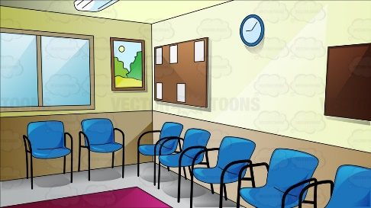
The nurse will call you when it is your turn. Mum will stay with you.

The nurse will take you to another room where they will ask you to sit on a chair. The nurse will ask mum a few questions.
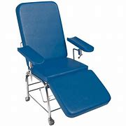

It is OK to feel a little worried.


You can think about your favourite things or look at a book, listen to music or play on your iPad.

The nurse will use a special wipe on your arm. This might smell strange, and it may feel cold, but it does not hurt.
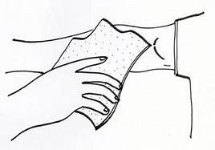

The nurse will wrap a band around the top of your arm which might squeeze or feel tight, but it does not hurt.


When the nurse puts the needle in your arm, you may feel a scratch.
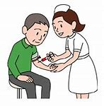

After the blood has been collected in a tube, the nurse will tape the cotton wool to your arm or put a plaster on.
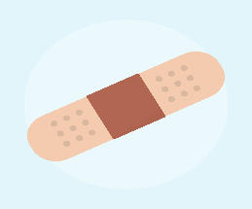
The blood test is now finished.


