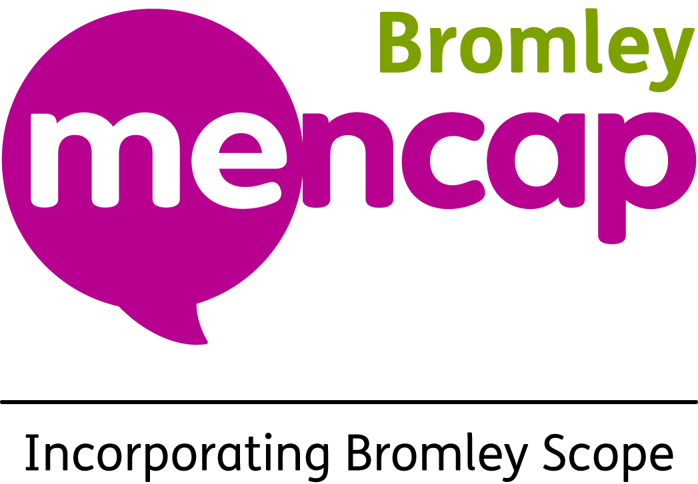
Bromley Mencap Registered Office:
Rutland House
44 Masons Hill
Bromley
Kent BR2 9JG
Tel: 020 8466 0790
enquiries@bromleymencap.org
www.bromleymencap.org.uk

Covering Statement for Bromley Mencap’s Organisational Response

Bromley Mencap and the disabled people and families we support have co-produced this organisational response to the government consultation on the Pathways to Work: Reforming Benefits and Support to Get Britain Working Green Paper. Our response was written following a series of consultation meetings and collecting direct contributions from those affected. It includes feedback from people with learning disabilities, physical disabilities, autistic individuals, carers, frontline professionals, and our specialist Employment and Education Team.
We must begin by stating that we believe the consultation process itself is fundamentally flawed. In terms of the structure, it was not fully accessible to those most impacted. Although Easy Read and alternative formats were made available, they were not published until a month after the consultation launched. In practice many people with learning disabilities or communication difficulties were unable to meaningfully access or respond to the consultation due to the pace, complexity, lack of time, and the sheer volume of the material. As one of our advisors put it:
“This would be far too complicated and lengthy for a lot of the clients we support…[it seems like] this is what the DWP want – to make it easier to push things through.”
In terms of the questions being asked, the consultation fails to properly consult on the most serious and impactful changes – particularly the significant restrictions to Personal Independence Payment (PIP) eligibility and linking eligibility for the Health Element of Universal Credit to PIP.
The consultation documents blur the purpose of PIP, implying that it is a proxy unemployment benefit. PIP is intended to offset the extra costs of disability – whether or not a person is in work. Many of the people we support rely on PIP to cover essentials such as transport, medication, or support that is not available through the NHS or social care. PIP allows people to live independently – it is not a luxury or an unemployment support payment. Removing PIP payments for many current claimants risks pushing more disabled people into poverty and removing essential, non-means-tested support.
The proposal to link access to the health element of Universal Credit to PIP entitlement is especially concerning. This approach would exclude many people with invisible, fluctuating, or mental health conditions who may not qualify under the new stricter PIP criteria, but who will continue to face serious barriers to work and require support.
The lack of formal consultation on the above, alongside the reduction in the value of the UC health element has created significant distrust and distress among our members. Several people have told us they are frightened, distressed, overwhelmed and uncertain about their future, considering the impact these changes will have on them if they are implemented. These are not abstract policy shifts – they are proposals that will massively impact people’s wellbeing, independence, and survival.
We welcome the government’s stated ambition to support more disabled people into work. However, that must be done through inclusive, person-centred support, not by withdrawing essential benefits. Disabled people must be empowered and not coerced to try work safely. Their support system must be grounded in fairness, trust, and co-production in the real sense.
The scheduling of the Second Reading of the bill for the day after the consultation period closes only adds to the sense that this is a flawed process. We hope the following submission – which includes direct quotes, lived experience, and expert frontline insight – will helpfully inform the next stage of policy development. Reforms of this scale must not be based on assumptions or focused solely on cost-saving priorities, but on the rights and needs of disabled people.

Sincerely,

Steve Barnes
Interim Chief Executive Officer
Bromley Mencap

