Summer Strategies
No school, different routines, and round-the-clock care. Parents of children with special needs are faced with their biggest challenge of the year when it comes to the six long weeks of summer.
Here are my top 5 tips for surviving the long (and hopefully warm) summer holidays.
1. Create a calendar & use visuals as well as sticking to routines, including bedtime!
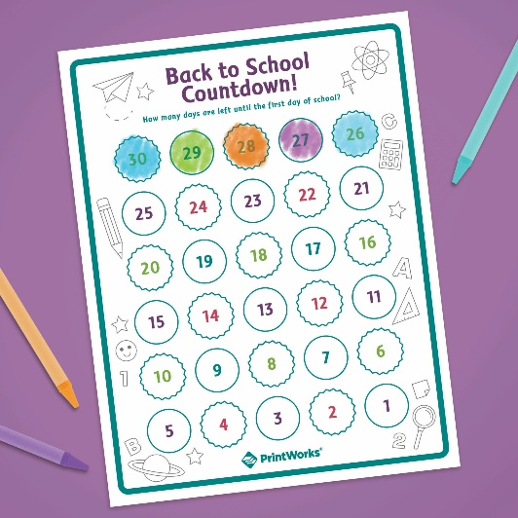
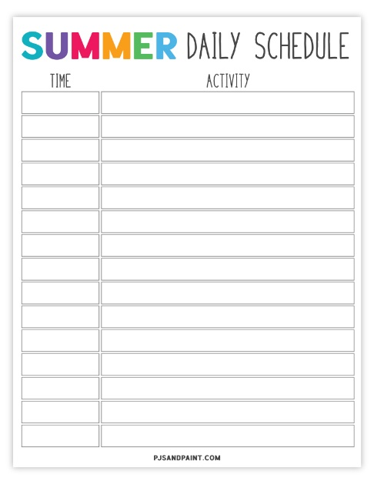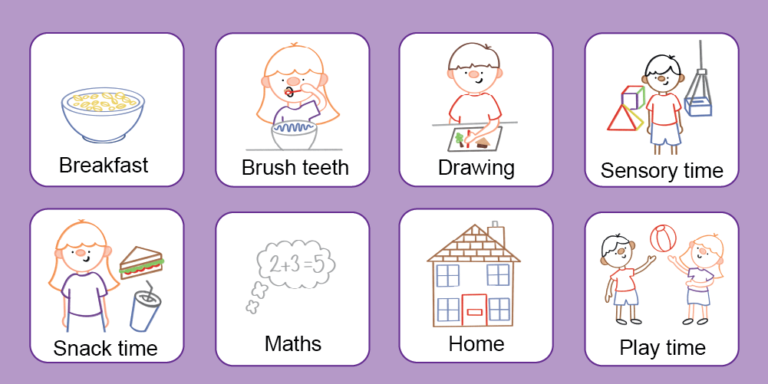
2.Include everyone & have a back up plan.
3.Do your research – research days out/busy/quiet times/ look up menus/quite areas. Look at the local offer: Special Educational Needs and Disability (SEND) Local Offer – London Borough of Bromley

4.Have your kit ready.
Sensory travel kits are a valuable way to give your child quick access to tools that support them during overwhelming or challenging moments. Involve your child in putting the kit together so they know what’s inside and feel a sense of ownership. Be sure to consider all the senses, and include items you know help your child to feel calm, focused, and regulated. Some shops like the Glades and Tesco’s can lend you sensory packs.
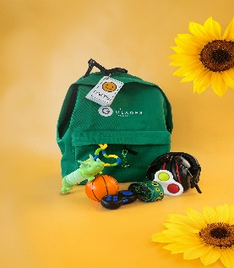

5.Create a scrapbook.
This will help with the transition back to school.
